

Content Management System

Wordpress

Akash Chaudhary (14bce016) | Portfolio | November 9th 2017

# Abstract

In this project we have used a WordPress site to make a portfolio website to display my resume and work until now. This is a faster and easy way to access the resume and also can be accessed from anywhere.

## What is content MAnagement system?

A content management system is the engine of a website. It allows users to create websites with text, photos and streaming media and can also send digests to customers via email and offer a fully functional and secure e-commerce gateway. And it can automatically update the user’s Facebook, Twitter and Instagram feeds.

Although a CMS ensures that even the smallest agency can create a website, security, accountability, accessibility and the  political scrutiny that comes with a website can place agency IT leaders in a fragile position.

An agency’s CMS is the point at which public service meets the public eye. Once agency information is posted online, it is in the public domain forever. That means content must meet archiving requirements that ensure information doesn’t disappear and is accessible for filling Freedom of Information Act requests. And any website failure will be visible to the public.

Link to my portfolio: <https://14bce016@wordpress.com>

**Screen shot:**

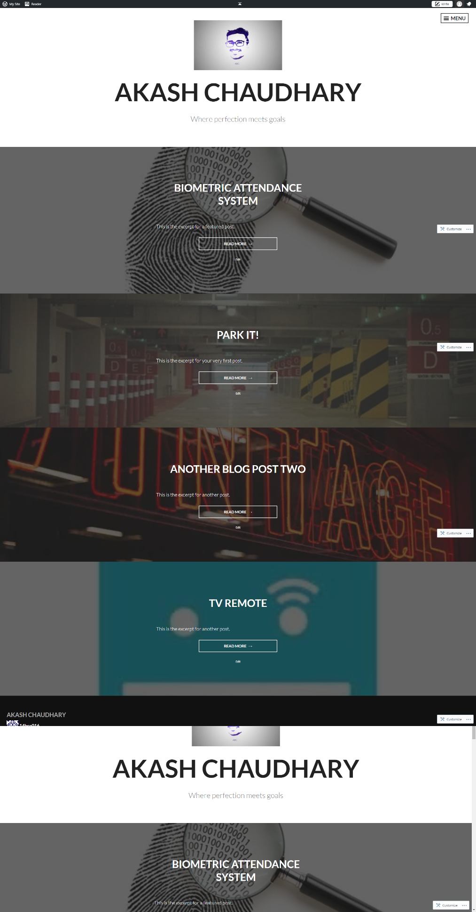

Widgets : Author, Blog stats (It shows the number of site hits), Contact and map (It uses google api and shows the location of the blogger for the purpose of contact)